ABIC SW 2018 H Tas

Simple Works Contract for Housing
in Tasmania

Contract Price: $

Owner:

Contractor:

Site:

Cooling-off period and withdrawal notice pursuant to Part 7 of the Residential Building Work Contracts and Dispute Resolution Act 2016 (TAS) (“Act”)

Cooling-off period

Notice to owner: The owner may end this contract within 5 clear business days after receipt by the owner of both a signed copy of the contract and the residential building consumer guide that is in effect under section 81(3) of the Act by filling in the notice below and giving it to the contractor in one of the following ways:

a personally

b leaving it at the address of the contractor set out in item 1 of schedule 1 of the contract with a person who appears to be at least 16 years old

c sending it by pre-paid certified mail to the address set out in item 1 of schedule 1 of this contract

d sending it by facsimile to the facsimile number (if any) or by email to the email address (if any) set out in item 1 of schedule 1 of this contract.

The owner cannot withdraw from this contract under the Act if:

a the contractor and the owner have previously entered into a residential building work contract the terms and contracted services of which are substantially the same as this contract; OR

b the owner received formal legal advice concerning the contract before entering into the contract.

Detach along dotted line

Notice that contract is ended

To ___________________________________________________ (contractor)

_______________________________________________________ (owner) gives notice that under section 33 of the Residential Building Work Contracts and Dispute Resolution Act 2016 (TAS) that the owner is withdrawing from the contract with the contractor and that the contract is ended.

Please refund any deposit paid by the owner to the contractor less $100 and any out of pocket expenses reasonably incurred by the contractor before the owner withdrew from our contract.

If no deposit was paid by the owner, the owner will pay the contractor $100 and any out of pocket expenses reasonably incurred by the contractor before the owner withdrew from our contract.

If the owner withdraws, the contractor is not entitled to more than the contractor would have been entitled to under the contract.

Owner’s signature:__________________________________

Date: __________________________

Schedules
1 Schedule 1 – Contract information 1
2 Schedule 2 – Special conditions 8
3 Schedule 3 – Order of precedence 10
4 Schedule 4 – Site information 12
5 Schedule 5 – Form of guarantee 13
6 Schedule 6 – Provisional sums 14
7 Schedule 7 – Prime cost sums 15
8 Schedule 8 – Items to be supplied by owner 16

A Overview
A1 Cooperative contracting 17
A2 Obligations of the contractor 17
A3 Warranties by the contractor 17
A4 Obligations of the owner 18
A5 Warranties by the owner 19
A6 Architect to administer contract 19
A7 Architect’s instruction 20
A8 Disputing architect’s certificate or written decision 20
A9 Disputing architect’s failure to act 20
A10 Failure to give certificate, written decision or notice 20
A11 Compensation is sole remedy 20

B Documents
B1 Discrepancies or omissions in documents 21
B2 Order of precedence of documents 21
B3 Supply of documents 21

C Security
C1 Security provided to owner 22
C2 Security to owner by cash retention 22
C3 Security to owner by *unconditional guarantees 22
C4 Owner’s right to draw on security provided to it 22
C5 Procedure for owner to draw on security provided
to it 22
C6 Owner’s release of security on *practical completion 23
C7 Owner’s release of security on final certificate 23

D Liability
D1 Risk before *practical completion 24
D2 Indemnity before *practical completion 24
D3 Risk after *practical completion 24
D4 Indemnity after *practical completion 25
D5 Reinstatement during period when contractor bears risk 25

E Insurance
E1 Public liability insurance 26
E2 Contract works insurance 26
E3 Entitlement to *input tax credit 26
E4 Insurance cover 27
E5 Limited right to arrange insurances 27
E6 Contractor and owner not to affect insurance 27
E7 Worker’s compensation and employer’s liability insurance 27
E8 Insurance claims 28
E9 Payment of excess 28
E10 Contractor entitled to make progress claim as a
result of loss or damage 28

F The site
F1 Owner to give contractor possession of the *site 29
F2 Contractor’s obligations in relation to the *site 29
F3 Owner warrants that it has given contractor the
*site information 29
F4 Contractor to examine the *site information 29
F5 Contractor discovers a *latent condition or *valuable item 30
F6 Architect to instruct in relation to a *latent condition
or *valuable item 30
F7 Contractor entitled to claim for *latent condition or
*valuable item 30

G Building the works
G1 Owner’s obligations 31
G2 Contractor’s obligations 31
G3 Contractor to appoint representative 31
G4 Subcontracting 31
G5 Contractor to give program to architect 31
G6 Contractor to give updated program 31
G7 Architect may instruct opening up or testing of the
*works 32
G8 Contractor entitled to claim for costs of opening
up or testing 32
G9 When contractor entitled to unfixed or demolished materials 32

H Claims to adjust the contract
H1 Time for making a *claim to adjust the contract 33
H2 Details required for claim 33
H3 Architect to assess claim 33
H4 Architect to give assessment 34
H5 Sum recoverable for claim for *adjustment of
time costs 34
H6 Architect may adjust contract in absence of claim 34

J Variation to the works
J1 Architect may instruct *variation to the *works 35
J2 Contractor to review instruction 36
J3 Architect to instruct whether *variation is to proceed 36
J4 If contractor receives written instruction to proceed 37
J5 Adjustment to the contract after written instruction
to proceed 37
J6 If *authorised person issues *official document 37
J7 Architect to give instruction 37
J8 Contractor entitled to claim for *official document 37
J9 Variation works under the Building Act 2016 37

K Adjustment of provisional and prime cost sums
K1 *Provisional and *prime cost sums included in contract 38
K2 Architect may instruct regarding *provisional
or *prime cost sum 38
K3 Architect may instruct contractor to use particular person for *provisional or *prime cost sum 39
K4 Adjustment for *provisional or *prime cost sum 39

L Adjustment of time
L1 Causes of delay which entitle making a claim for
adjustment of time with costs 40
L2 Causes of delay which entitle making claim for
adjustment of time without costs 40
L3 Contractor to notify of delay 40
L4 Contractor to allow for delays 41
L5 Adjustment of provisional allowance for delays 41
L6 Overlapping delays 41

M Completion of the works
M1 *Practical completion 42
M2 Inspection by the contractor 42
M3 Notification to architect of *practical completion 42
M4 Architect to decide if the *works have reached *practical completion 42
M5 If the *works not at *practical completion 43
M6 Contractor to bring the *works to *practical completion 43
M7 If architect fails to issue notice of *practical completion 43
M8 Possession of the *works before *practical completion 43
M9 Liquidated damages may be payable 43
M10 Deduction of liquidated damages 43
M11 Contractor to correct *defects and finalise work 44
M12 If the contractor fails to correct *defects
and finalise work 44
M13 Defects liability period 44
M14 Contractor’s obligations during and after defects liability period 44

N Payment for the works
N1 *Contract price 45
N2 Owner’s obligation to pay *contract price 45
N3 Progress claims – procedure for contractor 45
N4 Progress claims – procedure for architect 46
N5 *Tax invoice 46
N6 Certificates – obligation to pay 46
N7 Before making first progress payment 46
N8 If architect fails to issue certificate 47
N9 Contractor entitled to make claim 47
N10 Final claim – procedure for contractor 47
N11 Final certificate – procedure for architect 48
N12 Final certificate – *tax invoice 48
N13 Final certificate – obligation to pay 48
N14 Effect of final certificate 48
N15 Interest on overdue amounts. 48
N16 Payment of *deposit 49
N17 Time for assessing *deposit 49

P Dispute resolution
P1 Each *party to continue to perform its obligations 50
P2 Compulsory conference 50
P3 Mediation 50
P4 Legal rights 50

Q Termination of engagement
Q1 Owner may require contractor to remedy default 51
Q2 Owner may immediately terminate 51
Q3 Owner may take possession of the *site 51
Q4 Assignment of contractor’s rights 51
Q5 Owner may contract with others to complete the *works 51
Q6 Owner not bound to make further payment to contractor 52
Q7 Owner may pay subcontractors or suppliers 52
Q8 Architect to give assessment of cost of completing the *works 52
Q9 Architect to give certificate of amount payable to contractor or owner 52
Q10 Contractor or owner to pay under clause Q9 53
Q11 Contractor may require owner to remedy default 53
Q12 Contractor may suspend if default not remedied 53
Q13 Contractor’s subsequent right to terminate 53
Q14 Contractor may immediately terminate 53
Q15 Contractor’s entitlement after termination 54
Q16 Procedure for contractor to make claim 54
Q17 Architect to give certificate 54
Q18 Contractor or owner to pay under clause Q17 54
Q19 If this contract is frustrated 54

R Miscellaneous
R1 Transmission of documents 55
R2 Time document is received 55
R3 Assignment 55
R4 Entire contract 55
R5 Contract to benefit successors and assignees 55
R6 Severability 56
R7 Waiver 56
R8 Governing law 56
R9 Compliance with law 56
R10 Change in *relevant legislation 56
R11 Interpretation of headings 56
R12 Contractor and owner to observe confidentiality 56
R13 General interpretation 56

S Definitions 57

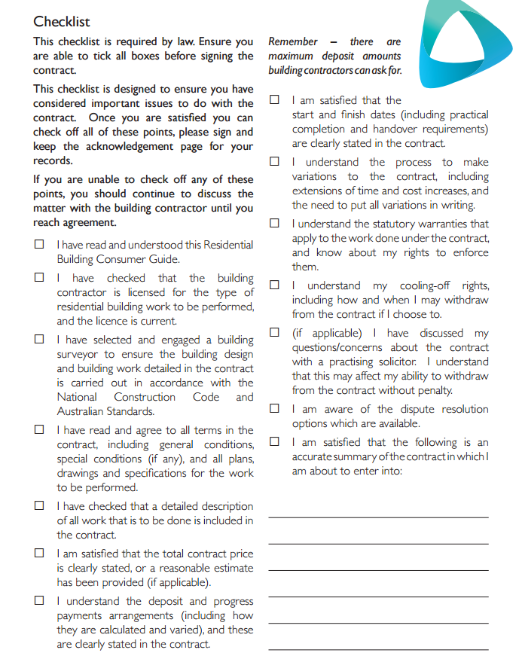

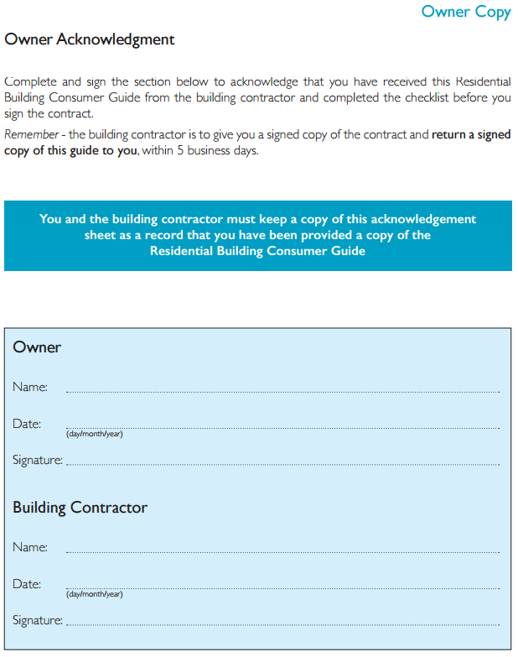

A most current version of the Residential Building Consumer Guide is available for download from CBOS (Tas): http://www.justice.tas.gov.au/building/consumer_building_information.

Item 1 | The owner | The contractor
Name:
ABN (if applicable):
Accreditation number:
Representative:
Address for notices:
Email:
Mobile:
Telephone:
Facsimile:
If the *party is an individual, individual trustee,
partnership or unincorporated association
Signed by *party:
Signed by witness:
Name of witness:
Date of signing:
If the *party is a corporation, corporate trustee or
incorporated association
Common seal of *party:
(if applicable)
Signed by:
Capacity: | Officer / Director / Secretary | Officer / Director / Secretary
Print name:
Signed by:
Capacity: | Officer / Director / Sole Director | Officer / Director / Sole Director
Print name:
Date of signing:

Item 1  Clause A5 | If the owner has financed the *works using a lending institution
 | Name of lender:
 | Representative:
 | Address:
 | Email:
 | Mobile:
 | Telephone:
 | Facsimile:
Item 2 | The architect
Clause A6 | Name:
 | Registration number
 | Representative:
 | Address for notices:
 | Email:
 | Mobile:
 | Telephone:
 | Facsimile:
Item 3 | Special conditions
Clause B2 | Are there any other special conditions? |  |  | Yes No
 | If yes, schedule 2a applies. |  |  | Strike out whichever doesn’t apply
 | Will the owner remain in occupation? |  |  | Yes No
 | If yes, schedule 2b applies. |  |  | Strike out whichever doesn’t apply
 | Signed: Owner: |  |  | __________________________________
 | Contractor: |  |  | __________________________________
Item 4 | The *contract price
Clause N1 | *Cost of building work: |  |  |  | $
 | Plus *GST |  |  |  | $
 | *Contract price |  |  |  | $
 | Signed: Owner: |  |  |  | ________________________________
 | Warning – The *contract price may be subject to adjustment due to the following:
 | Clause B2 | Order of precedence of documents
 | Clause E5 | Limited right to arrange insurances
 | Clause F7 | *Latent condition or *valuable item
 | Clause G8 | Costs of opening up or testing
 | Clause J1 | Architect may instruct *variation
 | Clause J8 | Claim for *official document
 | Clause K4 | Adjustment for *provisional or *prime cost sum
 | Clause L1 | Adjustment of time with costs
 | Clause M7 | Failure to issue notice of *practical completion
 | Clause M8 | Possession before *practical completion
 | Clause N8 | If architect fails to issue certificate
 | Clause N15 | Interest on overdue amounts
 | Clause R10 | Change in *relevant legislation
 | Signed: Owner: |  |  |  | ________________________________
Item 5 | The *works
Clause A2 | Brief description of the *works:
Item 6 | The *site of the *works
Clause A2 | The address/location of the *site:

Item 7 | Security provided by the contractor
Item 7a | Is the contractor to give security to the owner? |  |  |  | Yes No
Clause C1
 |  |  |  |  | Strike out whichever doesn’t apply
Item 7b | Owner’s nominated type of security: |  |  |  | Cash Retention  Unconditional Guarantee
Clauses C1
 |  |  |  |  | Strike out whichever doesn’t apply. If neither selected, cash retention is default
Item 8  Clause C2 | Percentage of *contract price for cash retention |  |  |  | %
 |  |  |  |  | If nothing stated, 5%
Item 9  Clause C3 | Percentage of *contract price for each *unconditional guarantee
 | Contractor gives 2 unconditional guarantees each of: |  |  |  | %
 |  |  |  |  | If nothing stated, 2.5%
Item 10  Clauses C6, C7, N6, N13, N16, Q10, Q18 | Period for payment of certificates and for release of security |  |  |  | calendar days
 |  |  |  |  | If nothing stated, 7 calendar days
Item 11 | Public liability insurance
Clause E1 | Is the owner or the contractor to take out and maintain public liability insurance?
 |  |  |  |  | If nothing stated, the contractor
Item 12 | Contract works insurance
Clause E2 | Is the owner or the contractor to take out and maintain contract works insurance?
 |  |  |  |  | If nothing stated, the contractor
Item 13  Clause E4.1 | Amount to cover fees of the architect and other consultants
 |  |  |  |  | If nothing stated, 10% of the *contract price
Item 14  Clause E4.1 | Amount to cover cost of demolition and removal of debris
 |  |  |  |  | If nothing stated, 10% of the *contract price
Item 15  Clause E4.2 | Amount of insurance for injury, illness, disease or death
 |  |  |  |  | If nothing stated, $20,000,000.00
Item 16 | Insurance excess
Clause E9 | Clause E1: Amount of excess for  public liability insurance:
 |  |  |  |  | If nothing stated, $1,000.00
Clause E2: Amount of excess for
contract works insurance:
 |  |  |  |  | If nothing stated, $1,000.00
Item 17  Clause H2 | Percentage for the contractor’s overheads and profit |  |  |  | %
 |  |  |  |  | If nothing stated, 15%
Item 18 | *Adjustment of time costs
Clause H5 | Stage of completion of the *works: |  |  |  | Sum per *working day (incl. *GST):
Item 19  Clause K4.2 | Percentage of difference to be added to the *contract price |  |  |  | %
 |  |  |  |  | If nothing stated, 10%
Item 20  Clauses L2, L4, L5 | Allowance for delay due to disruptive weather conditions |  |  |  | *working days
Item 21  Clauses L2, L5 | Other allowances for delay having regard to the nature of the contract and the *works which do not entitle *adjustment of time costs
 | Cause: |  |  |  | Allowance (*working days):
Item 22 | Date for *practical completion
Clause M1
Item 23  Clause M1 | Commissioning tests for *practical completion
Item 24 | Rate for liquidated damages |  |  |  | $ per calendar day
Clause M9 |  |  |  |  | (including any *GST)
Item 25 | Defects liability period for the *works |  |  |  | months
Clause M13 |  |  |  |  | If nothing stated, 12 months
Item 26 | Progress payments
Clause N3,  N4 | Description of each stage |  |  |  |  | Claimable percentage  of *contract price
1
2
3
4
5
6
Item 27  Clause N3 |  | Information to be included in a progress claim
Item 28 |  | Interest rate on overdue amounts | %
Clause N15 |  |  | If nothing stated, 10% per annum
Item 29 |  | Official documents
Item 29a |  | *Official documents required to begin the *works but to be obtained by the contractor:
Item 29b |  | *Official documents required to complete the *works but to be obtained by the owner:
Item 30 |  | *Deposit provided by owner
Item 30a  Clause N3, N4.2, N16 |  | Is the owner to give a *deposit to the contractor? |  | Yes No
 |  |  |  | Strike out whichever doesn’t apply
Item 30b |  | If yes in item 30a, the amount of *deposit is: |  | $ incl. *GST
Clauses N3, N4.2, N16 |  | which is also: |  | % of the *contract price
 |  | Refer to Information Statement for maximum deposit amounts permitted under the *Act |  | If nothing stated, $0.00 and 0%  Dollar value must not be more than the maximum percentage(s) in the *Act of the *contract price

Special conditions
Item 3 of schedule 1
Clause B2

The owner remains in occupation
Item 3 of schedule 1

These special conditions only apply for projects where the owner will remain in occupation during construction:

Replace the words “possession of” with the words “access to” in the following subclauses:

A2.1a

A4.1c

D1.1

D1.4c

E1.1

E2.1

E5.1a

F1

F1.1

G5.1

L1.1b

Replace clause D3.1 with the following:
Subject to clause D4, from the date of *practical completion, the owner bears the risks described in the following clauses.

Replace clause M1.3 with the following:
From 4.00pm on the day the architect issues the notice of *practical completion, the contractor ceases to have access to the *works except by prior arrangement with the owner.

Replace clause Q3.1b with the following:
the owner may exclude the contractor from the *site.

The order of precedence of *contract documents is:
Clause B2

1. The special conditions shown in schedule 2a.
2. The owner occupier conditions shown in schedule 2b.
3. The conditions set out in this contract and schedule 1.
4. The specifications described below:

5. The drawings listed below:

6. All other documents described below:

The *site information is:
Clause F3

Contractor’s *unconditional guarantee to the owner
Clause C3

for [insert amount $AUD]
in favour of [insert name of owner]

[Insert name of owner, and ABN if owner is a company] of [insert address] (owner) has entered into a written contract dated [insert contract date] with [insert name of contractor and ABN] of [insert address] (contractor) for the construction of the works described in that contract. The contract states that the contractor may elect to give security for the performance of the contract in the form of an unconditional guarantee.

[Insert name of security provider] unconditionally undertakes that if the owner gives it a written notice stating the basis and extent of its entitlement to draw on the undertaking and the amount to which it is entitled, the security provider will pay the owner the amount which the owner declares is due, up to a maximum of the combined amount of [insert amount $AUD] (the Amount).

It is not the responsibility of the security provider to investigate the accuracy or the reasonableness of the contents of the notice or the declarant’s capacity to give the notice. The security provider will make the payments without further reference to the contractor, despite any notice by the contractor or any other person to the security provider not to pay the whole or any part of the amount.

The security provider’s liability under this undertaking is not affected by any variation of the contract or by any waiver by the owner of any default by the contractor.

This undertaking remains in force until the first of the following events occurs:
- the owner notifies the security provider in writing that this undertaking is no longer required;
- the security provider pays the Amount to the owner;
- the owner informs the security provider that the contractor has performed all its obligations and paid all amounts required to be paid under the contract; or
- [insert date of expiry/termination of this undertaking].

This undertaking creates no rights in anyone except the owner and the owner’s successors and cannot be assigned.

This undertaking is governed by the law of [insert jurisdiction].

EXECUTED on [insert date] as a Deed.

Signed, sealed and delivered on behalf of [insert name of security provider] by its attorney [insert name and address of attorney of security provider] declaring it has no notification of the revocation of the power of attorney granted to it on [insert date] under which this undertaking is executed.
Signature of attorney
Signature of witness

*Provisional sums
Section K

Sum allowed |  | Description |  | Particular person†
$
$
$
$
$
$
$
$
$
$

† Note: If the owner intends on using a particular person to carry out the work for which a *provisional sum has been allowed the name of that person should be shown above. If the identity of the particular person is not known at the time that this contract is executed the intention to use a particular person should be indicated by inserting ‘Yes’ above in the column headed ‘Particular person’.

*Prime cost sums
Section K

Sum allowed |  | Description |  | Particular person†
$
$
$
$
$
$
$
$
$
$

† Note: If the owner intends on using a particular person to carry out the work for which a *prime cost sum has been allowed the name of that person should be shown above. If the identity of the particular person is not known at the time that this contract is executed the intention to use a particular person should be indicated by inserting ‘Yes’ above in the column headed ‘Particular person’.

Items to be supplied by the owner for incorporation in the *works
Clause N1

Items to be supplied by the owner and installed by the contractor (and only the costs of installation are included in the *contract price):

Items to be supplied and installed by the owner (and no allowance has been included in the *contract price for supply and installation):

